**Sprint Review and Retrospective**

**ChadaTech**

**Elizabeth Danzberger**

As the Scrum Master, I had a very important role to play during the initial development of the SNHU Travel project. I tried to be very clear from the outset about the procedures that would need to be followed, and gave clear information about the specific details. For example, during our initial switch to an agile framework I explained that we (I, as well as the Development Team, including Testers) would be participating in daily meetings at the start of each day – specifically 9:00 AM – called Daily Scrums. The Development Team was given 15 minutes, in which they were able to discuss some of the work that has been completed on the previous day, the work that needs to be completed during the current day, and some of the things that were inhibiting their ability to work efficiently. These topics are extremely important, because they help the team improve their overall workflow by being open with each other about the tasks at hand. It provides them with opportunities to ask each other questions and communicate with each other. There were times where some of the discussions contributed nothing, but I was able to swiftly pull the team back on track. Despite having to take the reigns at times, I was able to listen and simply *be present* when needed.

These are all things that have had very positive reviews from the Development Team. Since beginning Daily Scrums, the team has really connected and the overall communication between team members has been outstanding. They were able to work out issues related to workflow, although sometimes there were issues brought to my attention that needed further attention – the point is that the team brought up such issues confidently. However, the success from implementing Daily Scrums is notable, and it works. This directly contributed to the overall success of the project.

The Product Owner is responsible for communicating with users and stakeholders, as well as managing the product backlog and user stories. The Product Owner was constantly in communication with users and stakeholders in order to ensure that everyone has a clear understanding of the current state of the project and its requirements. They are very skilled at asking questions that provoke thought and allow the users to provide meaningful feedback. The Product Owner’s ability to translate these user-defined requirements into something that the rest of the Scrum Team can easily understand. Typically, the team does not interact directly with users or stakeholders, so this is a really important role that the Product Owner plays.

The user stories that were created by the Product Owner have been consistently well-defined, and when they do end up missing important details, the Development Team and Testers always feel comfortable contacting the Product Owner or Scrum Master about it. This level of communication is key. All in all, this aspect of the Scrum framework facilitated the completion of user stories. An example of this communication is provided further in the Sprint Review and Retrospective. These actions by the Product Owner have shown that they have directly contributed to the success of the SNHU Travel project.

Although the Development Team was able to incorporate testing into their workflow, the role that Testers have played in the project cannot be ignored. The Testers provided very detailed test cases for the user stories handed down by the Product Owner. These test cases were not so much focused on the *development* aspect of the user stories (how each function was implemented, etc. is left to the Development Team), but were able to provide clear test cases based on the goals of the user stories. There were times where the Testers needed more information in order to provide accurate test cases, and they needed to reach out in order to obtain this information from the Product Owner or the Scrum Master. The following email is an email that was sent from a Tester about this exactly, and is a wonderful example of this:

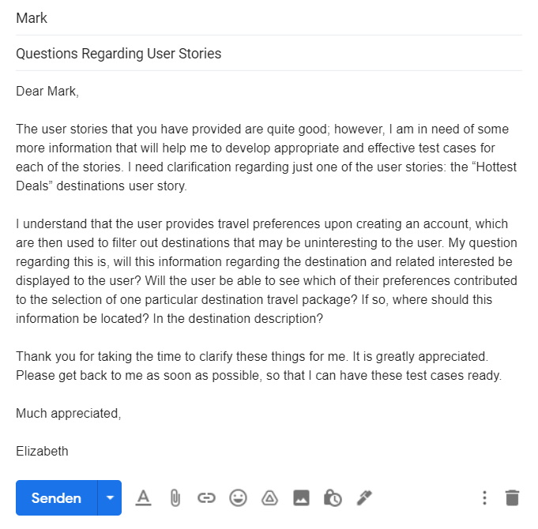Figure 1 - Email received by Mark (Product Owner) and sent by Elizabeth (Tester)

This proves that facilitating communication between the entire Scrum Team is the backbone of this framework, and indeed, the project as a whole. For this reason, the workflow of the Testers has directly contributed to the success of the SNHU Travel project.

The role of the Development Team in the project is obviously significant, but since we’ve migrated to an agile framework they have really excelled. During each sprint, it’s clear who is working on each item, and they are working really well together. They are broken up into small teams of 3-5 people, so they are able to concentrate on the task at hand. The Development Team has the maturity to operate independently without supervision, which has proven to be empowering and effective. As stated previously, the Development Team has shown that the ability to communicate is paramount – below is another email snippet which shows how the Development Team can properly communicate their needs when required:

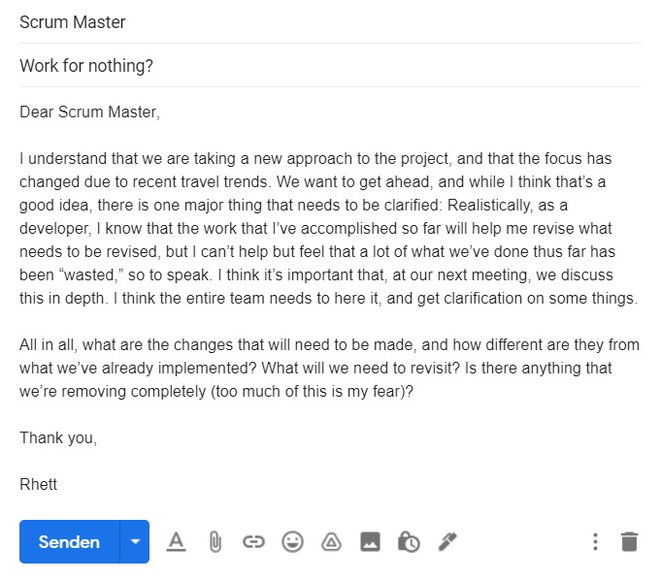Figure 2 - Email received by Scrum Master and sent by Rhett (Developer)

This particular member of the Development Team is reacting to a sudden change in the direction of the project based on recent travel trends. The developer came straight to the Scrum Master with their concerns, exhibiting their willingness to communicate in an effort to constantly improve their overall workflow. They are acknowledging the change in direction of the project, voicing their concerns, and most importantly, they are *asking questions*. This shows how the team can respond to sudden interruptions or change.

This certainly shows that the Development Team is capable of working independently and reaching out for information that they need in order to complete their work. The agile framework that we’re using as really helped them improve their workflow compared to the old waterfall model, and this directly contributed to the success of the SNHU Travel project.

Aside from the contributions from the Scrum Team, there are also organizational tools have helped the project exceed. For example, our use of a Kanban board and JIRA have proven to be beneficial. When we were using the waterfall model, there was not as much of a need to use these tools, but now that we’ve been using the Scrum framework they have really helped maximize our workflow and stay organized. One thing that has really helped the Development Team is the ability to track issues with tools such as JIRA. During the maintenance period of the project, this will be especially helpful so that we can track any bugs that appear. Our use of these tools has directly contributed to the success of the SNHU Travel project for these reasons.

There are advantages and disadvantages to everything, and agile frameworks are no exception. There needs to be a balance between various frameworks/methodologies, and some of them may be something brand new that works extremely well for your team specifically. However, when talking about our project in particular, the advantages outnumber the disadvantages. We’ll focus on the disadvantages, since everything described up until this point is about the advantages of the Scrum framework. One con that was noticeable upon our switch from waterfall to agile is that it took some of the team members quite some time to adjust to our new practices. One other significant con is that it became quite difficult to estimate the amount of time it will take in order to complete a given task or user story. This required us to run a few sprints and determine our overall workflow, but after that we were able to fine tune this.

Overall, our switch to agile was well-received by the team members and has been an unimaginable success thus far. If we were to fully implement the Scrum framework into our workflow company-wide, it would be of great benefit to our customers and to our team members, no matter their role.